

CS471 Web-Technologies

Lab week 2: The Internet protocols

Name: Reema Saleh, ID: 411202278

-----------------------------------------------

**Part 1: Capturing HTTP Traffic.**

*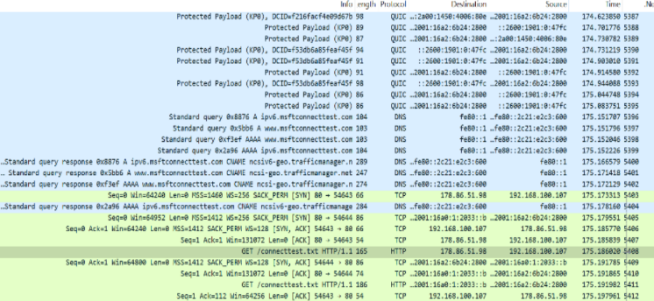Task 1: Start Wireshark and capture packets—> Done*.

*Task 2: Filter HTTP packets and analyze them:*

the HTTP request and response messages. Note the method (GET, POST), response codes (200 OK, 404 Not Found), etc.

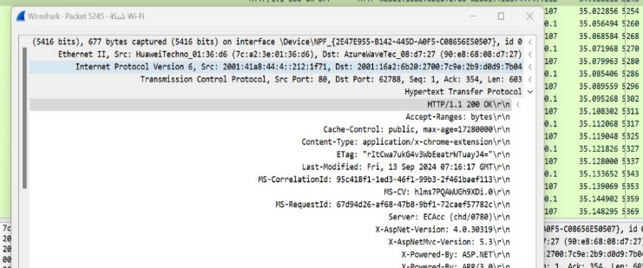



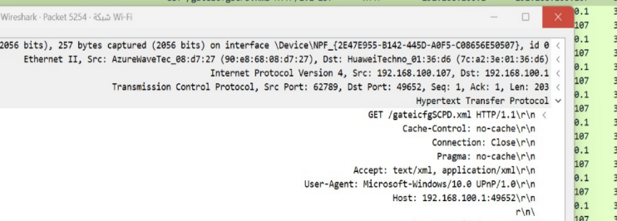



**Part 2: Analyzing TCP/IP Traffic.**

*Task 1: Filter TCP packets—>Done.*

Step 4: This shows the entire conversation between the client and server:

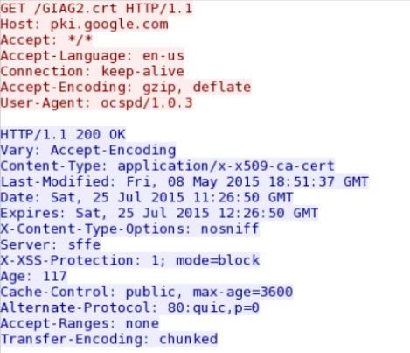

*Task 2: Analyze TCP handshake and investigate Data Transfer and Termination*

Step 1: Find and select packets related to the TCP three-way handshake: o SYN: Initiates a connection. o SYN-ACK: Acknowledges and responds to the SYN. o ACK: Acknowledges the SYN-ACK and establishes the connection.



Step 2: Note the sequence and acknowledgment numbers. Screenshot and upload your image to your online git repository.

Step 3: Observe the data packets exchanged between the client and server. Take a screenshot and upload it to your online git repo.

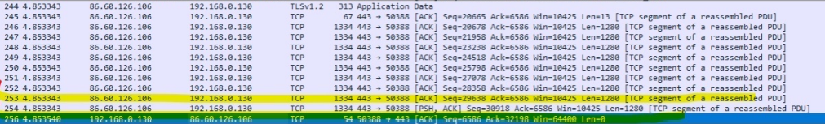



Step 4: Look at the TCP termination process (FIN, ACK packets).

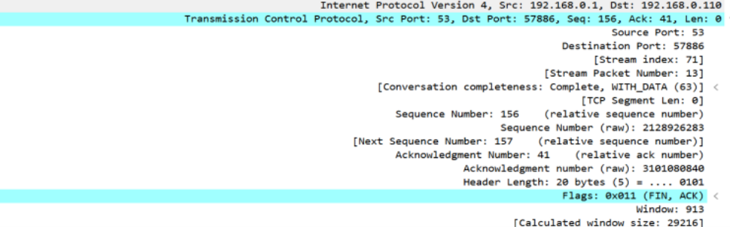

**Part 3: Capturing and Analyzing UDP Traffic.**

Task 1: Generate UDP traffic and capture packets 🡪Done

Task 2: Filter and analysis UDP Packets



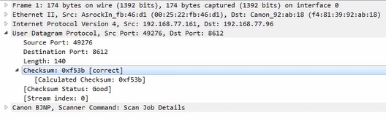

Step 5: Compare the simplicity of UDP headers with TCP headers.

|  |  |  |
| --- | --- | --- |
|  | UDP | TCP |
| Size | 8 bytes. | At least 20 bytes. |
| Fields | 4 (Source Port, Destination Port, Length, Checksum). | Multiple (Source Port, Destination Port, Sequence Number, Acknowledgment Number, Data Offset, Reserved, Flags, Window Size, Checksum, Urgent Pointer, Options). |
| Characteristics | Simple, minimal overhead, no connection management. | Complex, includes connection management, error control, and flow control mechanisms. |

**Part 4: Comparing TCP and UDP by filling in the following tables. Save your work (e.g., in an MS Word document), and upload it to your online git repo. Task 1: Fill in the following table and provide reasons.**

|  |  |  |
| --- | --- | --- |
|  | TCP or UDP | Reasons |
| Reliability and Connection Establishment | TCP | TCP ensures reliable communication because it sets up a connection with a three-way handshake and checks that data is received correctly. |
| Data Integrity and Ordering | TCP | Because TCP ensures data integrity and correct ordering by using sequence numbers and acknowledgment mechanisms, it provides reliable communication. |

Task 2: Identify the use Cases and Performance of TCP and UDP.

|  |  |  |
| --- | --- | --- |
|  | TCP | UDP |
| Use case | * Web browsing (HTTP\HTTPS) * Email (SMTP\IMAP) * File transfer (FTP) | * Online Gaming * Live video or audio streaming |
| Performance | Connection setup: Has setup time with a handshake.  Reliability: Reliable with error checking.  Speed and Efficiency: Slower due to overhead. | Connection setup: No setup time.  Reliability: Unreliable, no error checking.  Speed and Efficiency: Faster with less overhead. |

**The End of lab solution...**